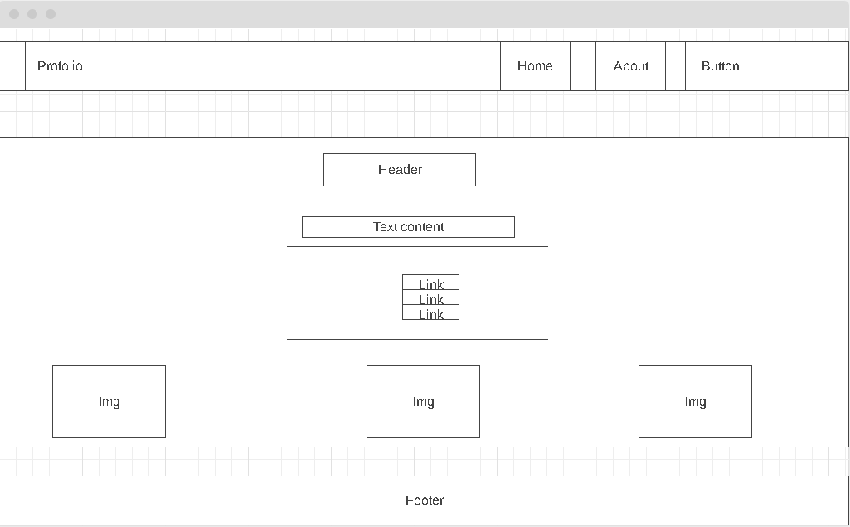

Font-Size: 2vh

Font-Size: 2.2vh

Font-Size: 2vh

Light Mode Background: Grey

Background: black